# Numerical Integration of Differential Equations: The Damped Harmonic Oscillator

*Tomasz Neska*

*10294857*

School of Physics and Astronomy

The University of Manchester

Second Year Computational Physics Report

April 2020

## Abstract

An analysis of four methods of numerical integration has been conducted. This was done to determine the most accurate and investigate the effect of the time step on the accuracy of the simulation. The four methods were Euler’s method, Improved Euler’s method, Euler-Cromer method and Verlet’s method. It was found that the Verlet method is the most accurate and that it is also symplectic. The relationship between the size of a time step and accuracy has been evaluated to be inversely proportional.

## Introduction

Simple harmonic motion is a type of motion that occurs in every area of physics where a small oscillation around a potential occurs. This means that in every field this form of oscillation is present due to the omnipresence of potentials in any system.

Simple harmonic motion is specified as a motion of a particle of mass *m* that is subject to a force characterised by its inverse proportionality to the displacement of the particle. Hence the characterising property of simple harmonic motion is that

|  |  |  |
| --- | --- | --- |
|  | $a∝ -x$*.* | Equation 1 |

It is a motion in 1 dimension along the line with the displacement *x* being the magnitude of the displacement from the equilibrium position. The acceleration of the particle *a* is obtained from the use of Newton’s second law and the addition of vector forces that act on a particle. This system is going to be the baseline on which the investigation into numerical methods is going to be conducted. The method of an iterative integrator is going to be explored and its effects on the energy of the system.

## Theory

For *a* being acceleration of a particle and *x* being the displacement from the point of equilibrium. If you consider a particle in a spring system with a damping force being dependent on the velocity of the object it is easy to derive that the equation of motion is given by

|  |  |  |
| --- | --- | --- |
|  | $m\ddot{x}+b\dot{x}+kx=0$*.* | Equation 2 |

This equation of motion represents a damped simple harmonic oscillator with *m* being the mass of the particle, *b* being the damping coefficient and *k* being the spring constant. The single dot represents a derivative with respect to time. This equation has 3 analytic solutions depending on the values of the constants. Those are: undamped oscillator, damped oscillator and overdamped oscillator. A fourth solution exists if the damping constant equals 0 but that solution is just the solution of a simple harmonic oscillator given by

|  |  |  |
| --- | --- | --- |
|  | $$x\left(t\right)=Asin\left(ω_{0}t\right)+Bcos(ω_{0}t)$$ | Equation 3 |

with $ω_{0}$ being the natural angular frequency of the oscillation which equals to $\sqrt{\frac{k}{m}}$. This solution has no damping term and can be derived from the undamped oscillator solution directly.

The solutions of the damped simple harmonic oscillator depend on the value of $α= - \frac{k}{m}+\frac{b^{2}}{4m^{2}}$. If $α>0$ the solution is the overdamped oscillation but if $α$ < 0 the solution is underdamped. However, if $α=0$ then the solution is critically damped.

Due to the use of iteration it should be said that the acceleration of a particle at any point of the iteration is given by Equation 2 in the form

|  |  |  |
| --- | --- | --- |
|  | $$a_{n}= -\frac{b}{m}v_{n}-\frac{k}{m}x_{n}$$ | Equation 4 |

Furthermore, the energy of the particle at any given velocity and position is obtained by

|  |  |  |
| --- | --- | --- |
|  | $E_{n}=\frac{1}{2}mv_{n}^{2}+\frac{1}{2}kx_{n}^{2}$*.* | Equation 5 |

The approximation described in section 3 is utilised during the investigation into a constant force being applied for a given time period. This approximation is given by

|  |  |  |
| --- | --- | --- |
|  | $x_{n+1}={Ax}_{n}+Bx_{n-1}+\frac{A^{'}\sin\left(ω^{'}nh\right)}{m}h^{2}$*.* | Equation 6 |

For $ω^{'}$ being the frequency of the force acting on the particle and $A^{'}$ being its amplitude. For the case of a constant force the sinusoidal force expression is replaced with a constant.

### 2.1 Euler’s method

The first numerical method is Euler’s method which is defined by

|  |  |  |
| --- | --- | --- |
|  | $x_{n+1}=x_{n}+hv_{n}$ and | Equation 7 |
|  | $v_{n+1}=v_{n}+ha_{n}$. | Equation 8 |

The variable *h* (in seconds) is the time step chosen for the simulation.

This method was found to not be a symplectic integrator. This can be confirmed by the application of Equation 6 and 7 with Equation 5. This obtains

|  |  |  |
| --- | --- | --- |
|  | $E_{n+1}=E_{n}(1+\frac{kh^{2}}{m})$*.* | Equation 9 |

This shows that the energy of the oscillator increases with each step. This gives an error term to the energy of O($h^{2}$).

### 2.2 Improved Euler’s method

The second numerical method is an improvement upon Euler’s method which is defined by

|  |  |  |
| --- | --- | --- |
|  | $x_{n+1}=x_{n}+hv_{n}+\frac{1}{2}h^{2}a_{n}$ and | Equation 10 |
|  | $v_{n+1}=v_{n}+ha_{n}$. | Equation 11 |

This method also doesn’t conserve energy and the energy error is given by

|  |  |  |
| --- | --- | --- |
|  | $E_{n+1}=E_{n}+O(h)$*.* | Equation 12 |

With *O(h)* being a polynomial with the dominant term being *h This* means that the energy will also be increasing as in the Euler’s method.

### 2.3 Euler-Cromer method

The third numerical method is a symplectic integrator which conserves average energy over the whole time period. It is defined by

|  |  |  |
| --- | --- | --- |
|  | $x_{n+1}=x_{n}+hv_{n+1 }$ and | Equation 13 |
|  | $v_{n+1}=v_{n}-\frac{kh}{m}x_{n}$. | Equation 14 |

Expanding the expression for energy we obtain

|  |  |  |
| --- | --- | --- |
|  | $E_{n+1}=E_{n}-\frac{1}{2}h^{2}\left(\frac{k^{2}{x_{n}}^{2}}{m}-k{v_{n}}^{2}\right)-h^{3}\left(\frac{k^{2}x_{n}v_{n}}{m}\right)+h^{4}(\frac{k^{3}{x_{n}}^{2}}{2m^{2}})$*.* | Equation 15 |

The second term averages out to be zero over the complete cycle what allows the energy to be conserved.

### Verlet’s method

The last numerical integrator is also a symplectic integrator which provides an accurate projectile path with not much more computational cost than Euler’s method. It is defined by

|  |  |  |
| --- | --- | --- |
|  | $x_{n+1}={Ax}_{n}+Bx_{n-1}$*.* | Equation 16 |

With $A=\frac{2\left(2m-kh^{2}\right)}{D}$ and $B=\frac{bh-2m}{D}$ with $D=2m+bh$. All the constants have the previously defined meaning. This method requires two initial positions and the value of $x_{1}$ is obtained utilising a Taylor expansion up to the second order. This gives

|  |  |  |
| --- | --- | --- |
|  | $x_{1}≅x_{0}+{hv}_{0}+\frac{1}{2}a_{0}h^{2} ≅ x\left(h\right)+ O(h^{3})$*.* | Equation 17 |

This allows for the computation of the positional terms. The velocity of the oscillator is computed utilising the Verlet-Störmer method along with the mean value theorem. The velocities are obtained by

|  |  |  |
| --- | --- | --- |
|  | $$v_{n}=\frac{x_{n+1}-x_{n-1}}{2}+O\left(h^{2}\right).$$ | Equation 18 |

This means that the error of the velocity utilising this method is given by the $h^{2}$ term in the expansion. As the velocity is defined utilising an average the influence of an external force can be evaluated. It is later seen in section 4.

The critical value of the damping factor is given by

|  |  |  |
| --- | --- | --- |
|  | $$b_{critical}=\sqrt{2km}$$ | Equation 19 |

## Method

The values of the constants were $k=0.93 Nm^{-1}$ and $m=5.44 kg$. The initial position was chosen to be $1 m$ with the initial velocity of $-1ms^{-1}$. No applied force was used.

The methods have been compared utilising a time interval of 100 seconds with the damping coefficient being equal to 0. This allows for the observation of the system at constant energy. The value of the time interval was varied between 1 second to 0.001 seconds. This allowed for the observation of the relation between the magnitude of the time step and the accuracy of the simulation. The methods were compared visually along with the use of the amount of “fictitious energy” that each simulation generated on top of the energy that the system possessed. Those were then graphed to show the relation between the error and time.

The program possesses an ability to write and load simulations. It does so by the means of a json file format. This was done to assure that the data is readable and can be utilised in different scripts. However, for the ease of data manipulation an object-oriented approach has been utilised. This was done to ensure maximum easiness in modifying the script later. This was done at the cost to memory usage that this script requires to run. This was addressed by resetting the variables after the results are obtained.

The investigation into the behaviour of a constant push force has been done with the use of Equation 6. The position of the oscillator was then plotted against time. The resonance curve was obtained using the same function. Instead of fixing the time during which the sinusoidal force acts it was chosen to be the entirety of the running time. The amplitude of the oscillation was then found and plotted against the frequency of the force. The natural frequency of the oscillator was found to be $0.41 rads^{-1}$. This gave the time period of $15.2 s.$ The constant force was hence applied at $45.6 s, 57.0 s, 47.1 s.$ This corresponds to 3, 3.75, and 3.10 of the periods respectively.

Meanwhile the sinusoidal force was investigated at the frequency of $0.01 Hz$ and $1 Hz$ with the magnitude of *1 N.*

The effects of the alteration of the damping coefficient were tested by using the Verlet method to calculate the position, velocity and energy and plotting them as functions of time. The damping term values investigated were multiples of the critical damping coefficient obtained by Equation 19. The mass, spring constant and initial conditions were used as before.

## Analysis

### 4.1 Comparison of the numerical methods

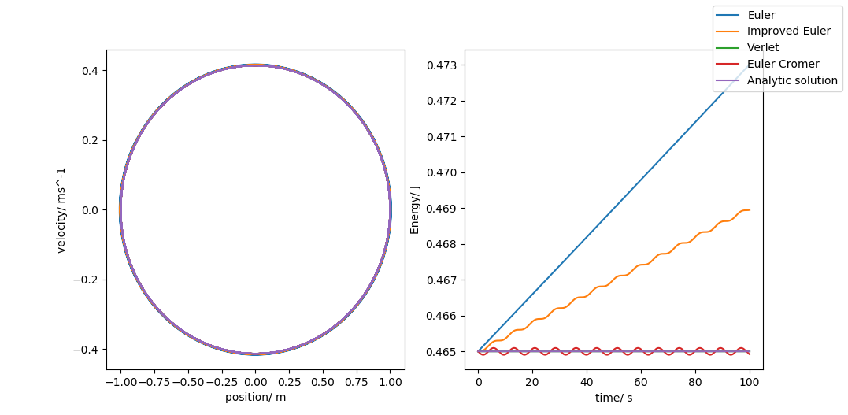Figure 1 shows that the Verlet methods gives the best results which can be further confirmed by the fact that the error in energy generated over the whole runtime was $0.096 J$ while the second lowest was the Euler-Cromer method which obtained $5.3 J$. The remaining two obtained an error of $\sim {10}^{4} J$. The inaccuracy in the Euler-Cromer method comes from the fact that its energy needs to be averaged over a complete cycle while the Verlet method doesn’t. The remaining two are not symplectic methods and it can be visually seen that they are not as accurate as the Verlet method. This means that the Verlet method was utilised for the rest of the investigation with modifications described in section 3.

Figure 1 – The phase plot of the oscillation (left) and the energy as a function of time (right). This plot was obtained with the time-step being *0.001 s.*

## Conclusion

## References

## Appendix - Code

The history of changes can be found in the GitHub repository [9].